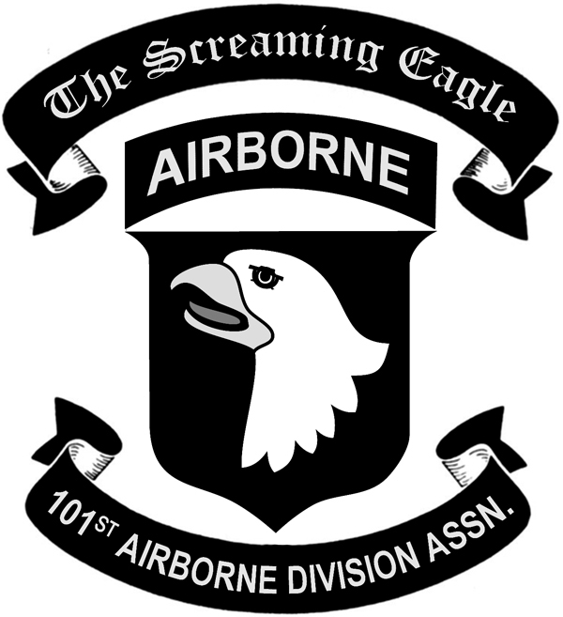
101st Airborne Division Association

MEMORANDUM

TO: Finance Committee:

Stephen Patterson, Chairman Phil Kallas, member Bruce Frederick, member Tom Sewell, member Bob Ponso, member J Alexander, member Chuck Slezak, member
Johnny Velasquez, member

FROM: Michael Tilden, Financial Administrator

SUBJECT: November Financial Reports

DATE: November 13, 2013

CC: Jim Keeton, National President
Jim Shamblen, National Vice President

Wayne St. Louis, Secretary-Treasurer
Joe Alexander, Chairman of the Board

Enclosed are the November 2013 financial reports that are being submitted for your information, review and acceptance. Expenses year to date are 4.09% of our annual budget; Income year to date is 5.79% of our annual budget. (See attached Income & Expenses - Actual vs. Budget).

Please note the balance of our checking contains the Scholarship donation monies which are sent to Smith Barney for investment the first of the month:

SE Foundation Checking #087 $34,654*
Subtotal: $34,654
Less 2014 Scholarship awards $6,227
Less SB Inv.Donations ($485)
Actual Operating balance: $27,942
Fund income received in November:
SE/Fund *$4,101
Scholarship: *$485 *Viste: *$0
*Sent to Smith Barney for investment/ Sent $70,000 S/E Funds for Investment

Hopefully I have provided all the information you require to properly and accurately evaluate the Foundation’s financial position as of November 30, 2013. If not, please let me know so I can institute changes prior to the next reporting period.

If you have any questions or concerns, I can be reached at (931) 431-0199 x31 or associationstore@comcast.net.

